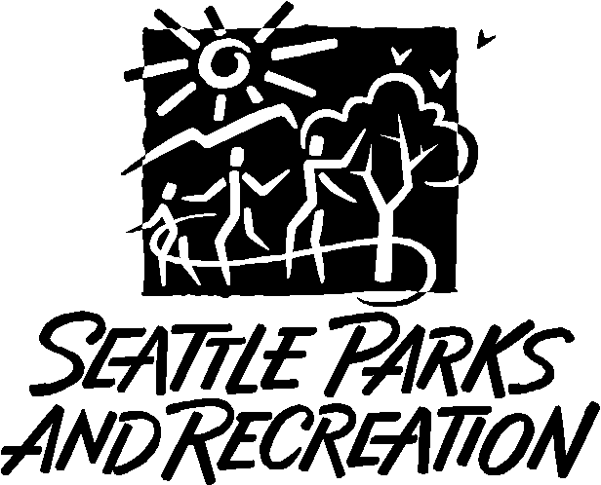
Seattle Parks and Recreation
WSDA Pesticide Application Record

Instructions: Please complete one block per application date and location. Type or print legibly in gray boxes. Under Total Quantity Applied record the total volume of mixture applied in gallons for mixture applications, record total quantity applied in fluid ounces for straight product applications, or record number of shells used for EZ-Ject lance applications.

Name of Person for Whom Pesticide was Applied:
Address of Person for Whom Pesticide was Applied:
Applicator’s Name:
Applicator’s Address:
Applicator’s Washington State License Number:
Miscellaneous Information:

Date | Start Time | Stop Time | Park Name | Wind Direction | Wind Speed | Temperature

Species | Method |  | Equipment |  | Application Area | Landscape type
 | ☐ cut/treat  ☐ foliar | ☐ injection | ☐ backpack sprayer  ☐ injection gun | ☐ lance  ☐ small bottle | ☐ spot  ☐ sq. ft.:  ☐ acres: | ☐ Forest  ☐ Grassland  ☐ Wetland

Full Product Name | EPA Registration Number | Mix or Straight Product? | Mix Rate  (in fluid oz./gallon) | Percent Concentration  of Each Product (%) | Total Quantity Applied  (mixture in gallons or single product in fl oz or gallons)

Date | Start Time | Stop Time | Park Name | Wind Direction | Wind Speed | Temperature

Species | Method |  | Equipment |  | Application Area | Landscape type
 | ☐ cut/treat  ☐ foliar | ☐ injection | ☐ backpack sprayer  ☐ injection gun | ☐ lance  ☐ small bottle | ☐ spot  ☐ sq. ft.:  ☐ acres: | ☐ Forest  ☐ Grassland  ☐ Wetland

Full Product Name | EPA Registration Number | Mix or Straight Product? | Mix Rate  (in fluid oz./gallon) | Percent Concentration  of Each Product (%) | Total Quantity Applied  (mixture in gallons or single product in fl oz or gallons)

Date | Start Time | Stop Time | Park Name | Wind Direction | Wind Speed | Temperature

Species | Method |  | Equipment |  | Application Area | Landscape type
 | ☐ cut/treat  ☐ foliar | ☐ injection | ☐ backpack sprayer  ☐ injection gun | ☐ lance  ☐ small bottle | ☐ spot  ☐ sq. ft.:  ☐ acres: | ☐ Forest  ☐ Grassland  ☐ Wetland

Full Product Name | EPA Registration Number | Mix or Straight Product? | Mix Rate  (in fluid oz./gallon) | Percent Concentration  of Each Product (%) | Total Quantity Applied  (mixture in gallons or single product in fl oz or gallons)

Date | Start Time | Stop Time | Park Name | Wind Direction | Wind Speed | Temperature

Species | Method |  | Equipment |  | Application Area | Landscape type
 | ☐ cut/treat  ☐ foliar | ☐ injection | ☐ backpack sprayer  ☐ injection gun | ☐ lance  ☐ small bottle | ☐ spot  ☐ sq. ft.:  ☐ acres: | ☐ Forest  ☐ Grassland  ☐ Wetland

Full Product Name | EPA Registration Number | Mix or Straight Product? | Mix Rate  (in fluid oz./gallon) | Percent Concentration  of Each Product (%) | Total Quantity Applied  (mixture in gallons or single product in fl oz or gallons)

Date | Start Time | Stop Time | Park Name | Wind Direction | Wind Speed | Temperature

Species | Method |  | Equipment |  | Application Area | Landscape type
 | ☐ cut/treat  ☐ foliar | ☐ injection | ☐ backpack sprayer  ☐ injection gun | ☐ lance  ☐ small bottle | ☐ spot  ☐ sq. ft.:  ☐ acres: | ☐ Forest  ☐ Grassland  ☐ Wetland

Full Product Name | EPA Registration Number | Mix or Straight Product? | Mix Rate  (in fluid oz./gallon) | Percent Concentration  of Each Product (%) | Total Quantity Applied  (mixture in gallons or single product in fl oz or gallons)

